Age Gate Implementation

Contents

Objective 2

Prerequisite 2

Module Implementation. 2

Definition file explained. 3

Resource strings. 3

App level configurations. 3

Business logic (age-gate.tsx) 3

View (age-gate.view.tsx) 4

Steps to test the sample module. 4

# Objective

This is a generic sample code for implementing an age-gate module. Age-gate module pops up at the page load. It will contain some information as a content-block and a consent button. Consent button will trigger an event to write cookie that suggests that the appropriate action has taken place.

**Sample implementation snapshot:**

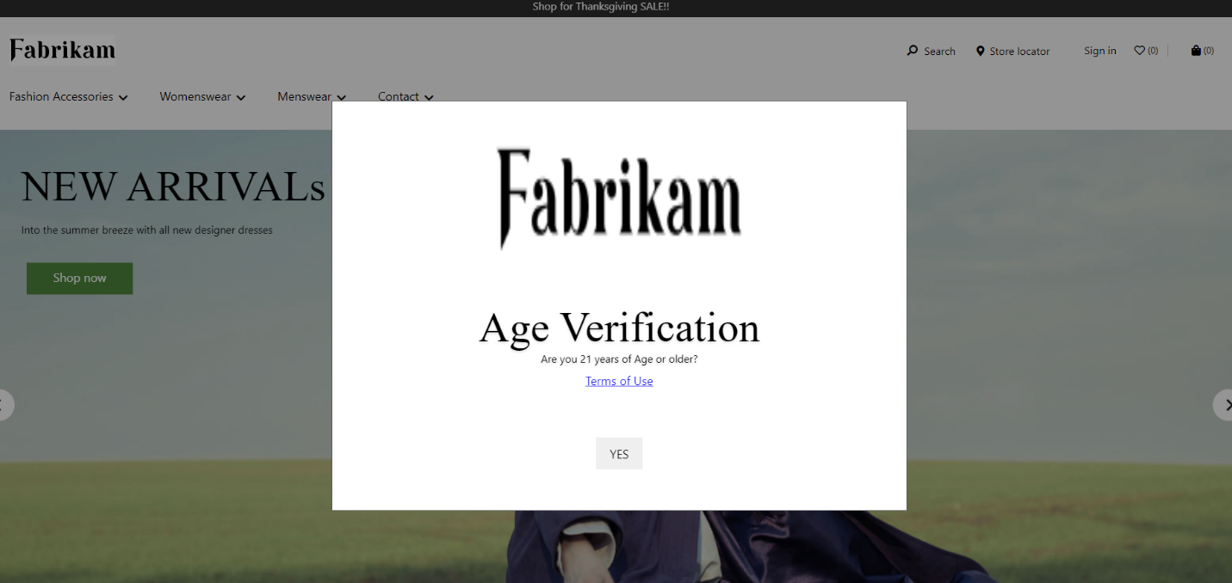

# Prerequisite

* SSK Module code need to be deployed and running.

Reference link: <https://docs.microsoft.com/en-us/dynamics365/commerce/e-commerce-extensibility/setup-dev-environment>

* Age gate configuration and its properties needs to be configured from authoring tool.

Reference link: <https://docs.microsoft.com/en-us/dynamics365/commerce/work-with-modules>

# Module Implementation.

Follow the process below to get started on age-gate module.

* 1. Unzip the age-gate source code.
  2. Copy the module code of age-gate module under “/src/module” as below:

# Definition file explained.

Please refer to the table below for configurable settings for this module based on the need.

**Configuration (age-gate.definition.json)**

|  |  |  |  |
| --- | --- | --- | --- |
| **Property Name** | **Type** | **Description** | **Default** |
| heading | String | Heading for age-gate module | - |
| className | String | A custom class name to target the CSS for this module | **-** |
| consentButtonText | String | Text for consent button | Yes |

# Resource strings.

|  |  |  |
| --- | --- | --- |
| **Key** | **Value** | **Description** |
| ageGateAriaLabel | Age Gate | Aria label for Age Gate modal dialog |

# App level configurations.

|  |  |  |  |
| --- | --- | --- | --- |
| **Property Name** | **Type** | **Description** | **Default** |
| ageGateCookieName | String | Optional cookie name for age gate module. It is a persistent cookie that expires in 2 days. If it is not passed, then the default cookie will take place. | _msdyn365__ageGate_ |

# Business logic (age-gate.tsx)

This module will be attached to the DOM as a modal dialog. It will contain content-blocks as per the need, configurable through CMS. Its initial state is determined by whether the cookie is present. It contains a consent button that emits an action which will write the cookie and close the modal dialog.

# View (age-gate.view.tsx)

There is a single view for this module, which is as a modal dialog.

# Steps to test the sample module.

1. **Build the repository**:

Execute yarn build from command line interface on your repository.

1. **Module Styling**:

CSS for this module(age-gate.scss) file should be placed in styles folder and the reference should be made in index.scss.

1. **Testing**:

Testing can be done by adding mock to the default-page.json mock in pageMocks and hitting your localhost like this: <https://localhost:4000/?mock=default-page>

**Note**: The sample code is tested on below package version:

